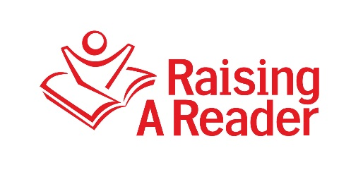

End of the Year Ideas:

Ideas for Blue Library Bag Events
Here are some fun ideas for your Blue Library Bag Events:
- Standard Graduations: This type of ceremony is typical and most popular. Students receive their blue bags during the closing activity in front of family and friends.
- Let’s Get Personal: This activity involves students decorating their Blue Bags by personalizing the bags to fit their own person individual style. Teachers can make this fun by providing all of the fun craft materials (glitter, ribbon, bedazzled jewels, colored glue, stencil and more) for students to simply personalize their Blue Bags.
- Good-Bye Red Bags; Hello Blue Bags!: This is a very sweet ceremony! Students create farewell poems or songs for their retired Red Book Bags and write promise letters/pledges to their Blue Library Bags telling the Blue Bags how they promise or pledge maintain the bags and use them for library uses.
- Host a Blue Library Bag Ceremony at the Local Library: This is an event that our NC affiliates partake in yearly. They sponsor a fund raiser for RAR t-shirts (for both students and teacher), food, and games. The event takes place in the local library and students are able to apply and receive their very first library card during the event. Once the students receive their Blue Bags they are able to check-out and fill their Blue Bags with their new library card.
Tips for Closing Out Your RAR Program
- Book bag rotation should probably end by or around Memorial Day. This is the time that many students stop coming to school.
- Store materials in a cool dry place:
  - Be sure to label the boxes with the teacher name, grade, and number of bags
  - Be sure to indicate the location of materials on an inventory spreadsheet or be sure to leave that information with a school administrator.

